CSC 235, Introduction to Linux &

Linux Administration

Fall 2023

**Assignment #4: System Configuration and Hardware Information**

**Due: Sunday, September 24, 2023 (NLT 23:59)**

**Instructions:**

1. Insert your answers into this document (*text and screenshots*)
2. Highlight your answers in green (*text only*)
3. When finished, rename the document (*please use the naming convention below*)
4. Upload the renamed document to the Moodle assignment

**A4 - last name, first name.docx** (e.g., **A4 - Wilcox, Dean**)

1. Follow the guidelines, show screenshots, and answer questions where needed.

Log into your root directory and display the CPU information using the command lscpu. Provide a screenshot, and identify the following:

a. Architecture

b. Vendor ID

c. Model number and model name

d. Cashe size

**Answer:**

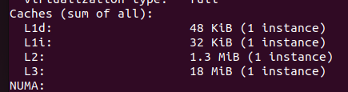

On Linux based system most of the hardware information can be extracted from the /proc file system, for example, to display CPU and memory hardware information, enter the following cat command:

* cat /proc/meminfo
* cat /proc/cpuinfo
* less /proc/cpuinfo

Identify the following:

e. CPU MHz

f. CPU Family

**Answer:**

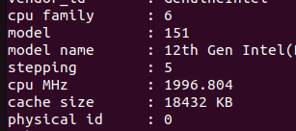

2. Linux uses the free command to identify free & used memory in the system

You can type the free command to check free memory

free

free -m

free -mt

free -gt

What is the difference between the four commands?

Free – shows memory usage in KB

free -m - shows memory usage in MB

free -mt – Shows MB and includes total line

free -gt Shows in GB and includes total line

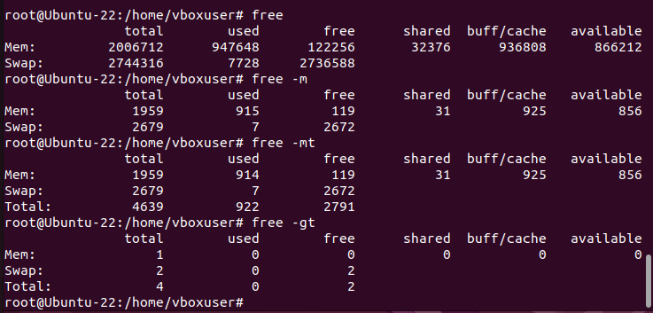

3. Find the current running Linux kernel version

a. Type the following command and show the output

cat /proc/version

**Screenshot:**

b. What does the uname command show you?

uname -mrs

uname -a

**Answer:**

The uname command shows system information about the OS and the Kernel.

c. free command and specific info in /proc directory and then for very specific info, such as memory, cache and swap you can specify as below. Notice I used egrep to search the log file. First, try cat /proc/meminfo and then the same with egrep as in the screenshot below.

The command option displays the following:

1. **total**: Total installed memory (MemTotal and SwapTotal in /proc/meminfo)

2. **used**: Used memory (calculated as total – free – buffers – cache)

3. **free**: Unused memory (MemFree and SwapFree in /proc/meminfo)

4. **shared**: Memory used (mostly) by tmpfs (Shmem in /proc/meminfo, available on kernels 2.6.32, displayed as zero if not available)

5. **buffers**: Memory used by kernel buffers (Buffers in /proc/meminfo)

6. **cache**: Memory used by the page cache and slabs (Cached and Slab in /proc/meminfo)

7. **buff/cache**: Sum of buffers and cache

8. **available**: Estimation of how much memory is available for starting new applications, without swapping. Unlike the data provided by the cache or free fields, this field takes into account page cache and also that not all reclaimable memory slabs will be reclaimed due to items being in use (MemAvailable in /proc/meminfo, available on kernels 3.14, emulated on kernels 2.6.27+, otherwise the same as free)

*Note: Buffering is the process of preloading data into a reserved area of memory called buffer memory. Buffer memory is a temporary storage area in the main memory (RAM) that stores data transferring between two or more devices, applications, or services.*

**Screenshot:**

Sorry, but I’m not entirely sure what I’m supposed to screenshot and put here. I followed all commands and saw how they worked, just not sure if something was missing in this document that was telling me what to take a screenshot of.